**Database Design Introduction**

Yankee Candle is one of the famous brands for manufacturing and retailing the scented candles, candleholders, and accessories. Its products are sold through online, thousands of gift shops and the Yankee candle stores. Moreover, this brand is well known globally that nearly 50 countries worldwide import these candles from the United States for sale. To grasp the understanding about the history of Yankee Candle, this company was first started in South Hadley, Massachusetts in 1969. They started as a small gift shop then they gradually expanded their business due to the high demands of the customers. After decades of expansion, Yankee Candle became who they are in these days: the world-famous candle retailer and manufacturer.

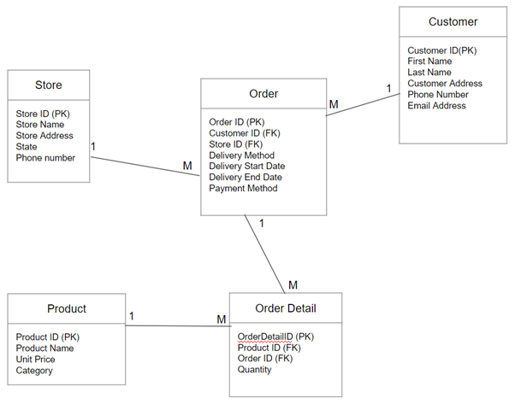The list of our team members’ names is as follow: WonBok Lee, Sangwon Baek, and Joonhyuk Kong.

**Relational Database Design: Yankee Candle**